Waterloo Secondary School
Information Technology
Form 4
Spreadsheet Assessment
45 minutes

1. Scenario
You have been asked by a teacher to prepare a spreadsheet showing the examination results of ten students in five subjects. The teacher needs the spreadsheet to calculate each student’s total score, percentage, and pass/fail status automatically. The teacher also wants to identify the highest and lowest average scores.
You must create a spreadsheet that accurately presents the information in a clear, professional format.
2. Specific Instructions
- Open Microsoft Excel.
- Create a worksheet named Examination Results.
- Start at A1 and type the following headings: Student Name, Mathematics, English, IT Science, Social Studies. (See data set below)
- Enter the names of the ten students and their marks in the five subjects.
- Add a heading in G1 named Total.
- Enter the formula in G2 to calculate the total score for the first student.
- Copy the formula down to calculate the total scores for the rest of the students G3 to G11
- Add a heading in H1 named Average.
- Enter the formula in H2 to calculate the average mark for the first student.
- Copy the formula down to calculate the average scores for the rest of the students H3 to H11
- Add a heading in I1 named Pass/Fail.
- Use the IF function to display "Pass" if a student scores at least 50 in every subject and "Fail" if the student scores below 50 in any subject.
- Identify the highest and lowest average scores.
- Format the spreadsheet neatly and save it as Form4_Examination_Results.

Sample Data Set
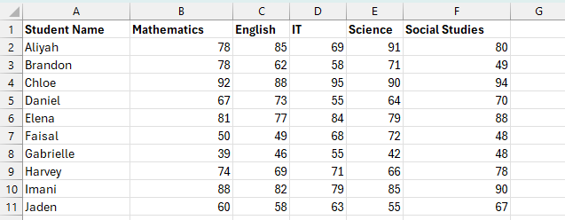

Performance Assessment Rubric
Assessment Criterion | Marks
Correctly names worksheet | 2
Enters data correctly | 5
Uses SUM correctly to calculate total scores | 4
Uses AVERAGE accurately to calculate average scores | 4
Constructs and applies the IF formula correctly | 6
Uses MAX and MIN to find the highest and lowest average score | 4
Formats the worksheet appropriately | 3
Saves the worksheet with the correct name | 2
Total | 30

